LAB REPORT

PF LAB PROJECT

FINDING AN INVERSE OF ANY 2X2 MATRIX

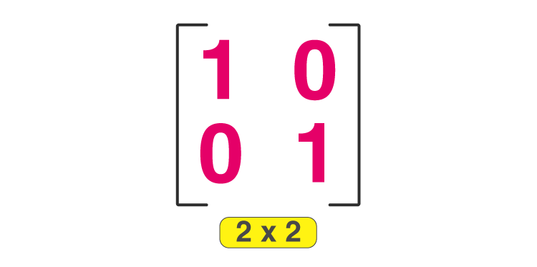

* Abdul Moiz Malik (210201082)

# Project Description:

Something that is the opposite or reverse of something else is known as inverse. Inverse operations are pairs of mathematical manipulations in which one operation undoes the action of the other. For example, addition and subtraction, multiplication and division. The inverse of a number usually means its reciprocal, i.e. x - 1 = 1 / x. The product of a number and its inverse (reciprocal) equals 1.

# Formula:

# The inverse matrix formula for a matrix A is given as,

* A-1 = adj(A)/|A|

# Adjoint of a 2x2 Matrix:

The adjoint of a matrix is the transpose of the cofactor matrix C of A,   
Adj (A)=CT

For example:

A = $\left[\begin{matrix}5 & 4 \\ 8 & 10\end{matrix}\right]$

Is

Adj (A)= $\left[\begin{matrix}10 & -4 \\ -8 & 5\end{matrix}\right]$

# Determinant of a 2x2 Matrix:

The determinant is a scalar value that is a function of the entries of a square matrix. The determinant of a matrix *A* is denoted det(*A*), det *A*, or |*A*|.   
For example:

A = $\left[\begin{matrix}5 & 4 \\ 8 & 10\end{matrix}\right]$

And

|A|= (5x10) – (8x4) => 18

# Details of Inverse of a Matrix:

Inverse of Matrix for a matrix A is denoted by A-1. The inverse of a 2 × 2 matrix can be calculated using a simple formula. The inverse of matrix is another matrix, which on multiplying with the given matrix gives the multiplicative identity.

The inverse of matrix is used of find the solution of linear equations through the matrix inversion method.

# Functionality of the program:

This python code will help the user to find the inverse of the matrix inputted. The matrix should have a 2x2 size. In simpler words, the result of any of the matrix will be an identity matrix which is represented by 1s on the main diagonal, and 0s everywhere else. Firstly, we will enter the number of rows and columns (which will be 2x2). Then, will enter the values to store inside the matrix, which will be later on appended in the lists. After this, the matrix will be displayed and we will proceed to the determinant part of the program. In this part, the program will find the determinant of the inputted values and then proceed to find the adjoint of the matrix. After all of the above mentioned procedure, the adjoint will be divided by the determinant and hence the inverse of the matrix will be calculated. The program is designed in a way that it will divide each of the element of the matrix one by one which will guide to a more accurate result. Now, to find the identity matrix, the program multiplies the inverse with the original matrix creating the identity matrix as a result. Again, the process will occur in different steps which may result in simplicity of the code and more accurate result.

<<The graphical representation of the program is displayed on the next page>>

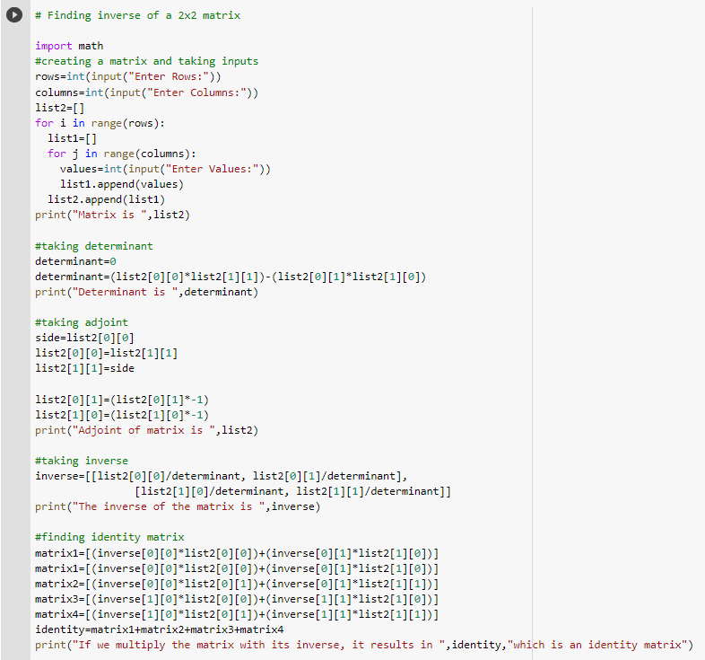

<<The results of the above mentioned program is displayed on the next page>>

# Result:

Following is the result of the above mentioned code which concludes the inverse of the matrix and then the proof of the identity matrix.

